Test # 244
Instrument Name Consistometer
Instrument Type Consistometer
Test Start 26/03/01 14:28
Test Stop 4:38:38
Well ID # Khvalynskaya #3
Customer LUKOIL
Cement Class G
Additives 0.1%THR-100+5.4%Microseals+20%SilicaF+Defoamer
Cement Mfr DYKERHOFF
BHCT 80
BHST 107
Density 1650
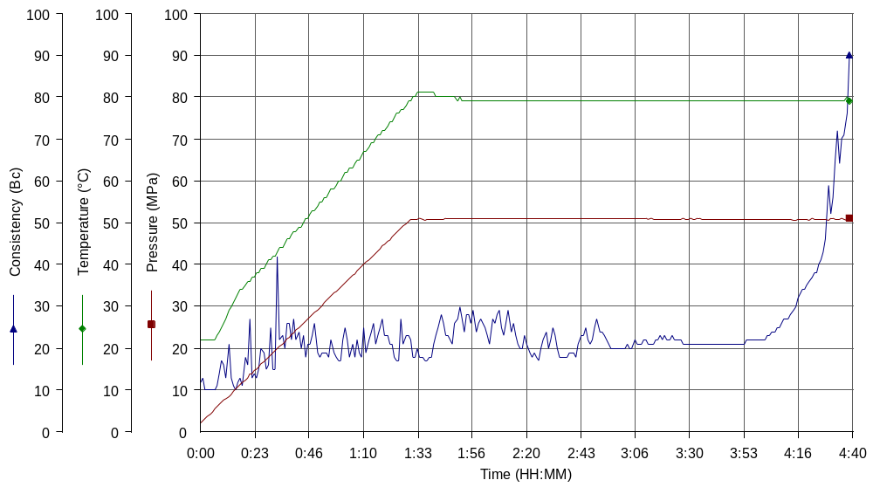

Test # 215
Instrument Name Consistometer
Instrument Type Consistometer
Test Start 06/03/01 19:44
Test Stop 13:07:16
Well ID # KHVALYNSKAYA #3
Customer LUKOIL
Cement Class G
Additives 0.1%THR-100+5.4%Microseals+20%SilicaF+Defoamer
Cement Mfr DYKERHOFF
BHCT 95
BHST 121
Density 1650
Fluid Loss
Job Type 245MM CSG
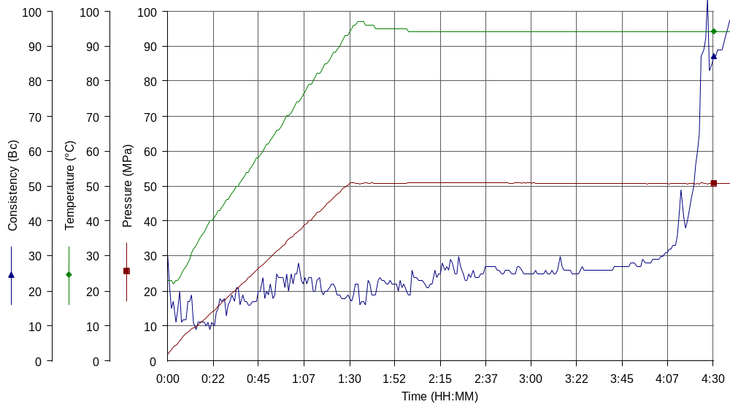
Comments MPa: 50.7(90min); T: 95C(90min)

